**D.K.T.E. Society’s Textile and Engineering Institute, Ichalkaranji.**

**(An Autonomous Institute, Affiliated to Shivaji University, Kolhapur)**

**Department of Computer Science & Engineering**

**2021-2022**



**Project SRS and Design Report On**

**BRAIN TUMOR DETECTION**

**Under The Guidance Of**

**T. I. Bagban**

**Submitted By:**

|  |  |
| --- | --- |
| **PRN NO.** | **NAME** |
| 18UCS107 | Rounak Shah |
| 18UCS108 | Ibtesam Shaikh |
| 18UCS113 | Muskan Shirgave |
| 18UCS118 | Yashada Thombre |

**T. I. Bagban Prof. (Dr.) D.V. Kodavade**

**Project Guide Head of Department**

**D.K.T.E. Society’s Textile and Engineering Institute, Ichalkaranji.**

**(An Autonomous Institute, Affiliated to Shivaji University, Kolhapur)**

**Department of Computer Science & Engineering**

**2021-2022**

**CERTIFICATE**

**This is to certify that,**

|  |  |
| --- | --- |
| **PRN NO.** | **NAME** |
| 18UCS107 | Rounak Shah |
| 18UCS108 | Ibtesam Shaikh |
| 18UCS113 | Muskan Shirgave |
| 18UCS118 | Yashada Thombre |

Have successfully completed the SRS and Design document entitled,

**Brain Tumor Detection**

In partial fulfillment for Project in semester –VII final year B.Tech CSE academics. This is the record of their work carried out during the academic year 2021-22.

Date: Place: Ichalkaranji

Mr.T. I. Bagban

PROJECT GUIDE EXTERNAL EXAMINER

Prof. (Dr.) D.V. Kodavade Prof. (Dr.) P.V.Kadole HEAD OF DEPARTMENT DIRECTOR

**ACKNOWLEDGEMENT**

We would like to express our deep gratitude to our project guide, Mr. T. I. Bagban, Associate Professor, Department of Computer Science and Engineering, DKTE, for his guidance with unsurpassed knowledge and immense encouragement. We are grateful to Prof. (Dr.) D.V.Kodavade , Head of the Department, Computer Science and Engineering, for providing us with the required facilities for the completion of the project work.

We are very much thankful to the Director, Prof. (Dr.) P.V.Kadole, for their encouragement and cooperation to carry out this work.

We express our thanks to all the teaching faculty of the Department of CSE, whose suggestions during reviews helped us in accomplishment of our project and also for providing us the lab resources in accomplishment of our project. We would like to thank our parents, friends, and classmates for their encouragement throughout our project period. At last but not the least, we thank everyone for supporting us directly or indirectly in completing this project successfully.

Thank you,

|  |  |
| --- | --- |
| **PRN NO.** | **NAME** |
| 18UCS107 | Rounak Shah |
| 18UCS108 | Ibtesam Shaikh |
| 18UCS113 | Muskan Shirgave |
| 18UCS118 | Yashada Thombre |

**INDEX**

|  |  |  |
| --- | --- | --- |
| **Sr. No.** | **Title** | **Page No.** |
| **1.** | **Introduction** | **5** |
| **2.** | **Usage Scenario**  2.1 User profile  2.2 Use cases  2.3 Use case diagram  2.4 Use case description  2.5 Activity Diagram | **8** |
| **3.** | **Data Model and Description**  3.1 Database  3.2 Complete data model | **12** |
| **4.** | **Functional Model and Description**  4.1 Class Diagram  4.2 Software Interfaces | **14** |
| **5.** | **Behavioral Model Description**  5.1 Events  5.2 States  5.3 State-chart Diagram | **15** |
| **6.** | **Restrictions Limitation and Constraints** | **17** |
| **7.** | **Detailed Design**  7.1 Components  7.2 Pseudocode | **18** |
| **8.** | **Validation Criteria**  8.1 Test plan  8.2 Expected final software response | **20** |
| **9.** | **Preliminary Schedule and Budget** | **21** |
| **10.** | **References** | **22** |

**1.INTRODUCTION**

The human brain is the major controller of the humanoid system. The brain tumor is affecting many people worldwide. It is not only limited to old age people but also detected in early age.

Brain tumor is the collection or mass of abnormal cells in the brain. A brain tumor is the abnormal growth of cells inside the brain cranium which limits the functioning of the brain. Our brain is enclosed by a skull which is very rigid and Any growth inside such a restricted space can cause many problems for humans. Brain tumors can be both cancerous(malignant) or noncancerous (benign). The pressure inside the skull increases when benign or malignant tumors grow. This will result in brain damage, and it can be life-threatening.

Brain tumors usually appear in various locations with different dimensions and shapes. Early detection of tumor cells can save a large number of human lives. Detecting the brain tumor and its stage undergoes a very complicated and time consuming process. The patient refers to MRI when some symptoms related to the tumor appear.

After examining the brain images, if tumor existence is suspected, the patient’s brain biopsy comes into action. Biopsy is an invasive procedure and in some cases it may even take up to a month for a definite answer. But the main concern with the biopsy is that it is not 100% accurate which may result in a serious diagnostic error followed by a wrong clinical management of the disease.

Machine learning based approaches like Deep Convolutional Neural Network (CNN)in radiology and other medical science fields play an important role to diagnose the disease in a much simpler way as never done before and hence providing a feasible alternative to surgical biopsy for brain tumors .

In this project, we attempting to detect and classify the brain tumor by processing the MRI of brain. So we focus mainly to design a better approach for the detection of the tumor.

* 1. **Goals and Objectives :**
* Literature survey of various brain tumor detection techniques
* Identify current brain tumor scenarios in a medical field.
* Identify suitable features for detecting brain tumor
* Collect and preprocess dataset required for detecting brain tumor
* Detection of brain tumor at an early stage by building a model using CNN technique
* Testing and finetuning the model

**1.2 Scope:**

Our aim is to develop an automated system for enhancement, segmentation and classification of brain tumors. The system can be used by neurosurgeons and healthcare specialists. The system incorporates image processing, pattern analysis, and computer vision techniques and is expected to improve the sensitivity, specificity, and efficiency of brain tumor screening.

The primary goal of medical imaging projects is to extract meaningful and accurate information from these images with the least error possible. The proper combination and parameterization of the phases enables the early diagnosis or the monitoring of the tumor identification.

In future, other features can also be added in the project that can provide more information about the tumor present in the brain. The feature may provide information about the percentage of brain affected with the part of the brain affected and may also provide remedies for the tumor present.

**ARCHITECTURE DIAGRAM**

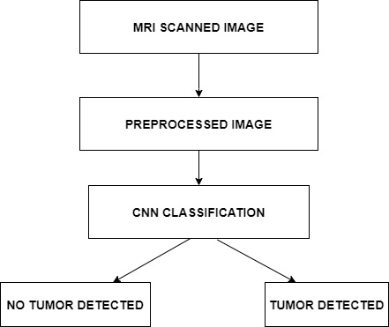

**2.USAGE SCENARIO**

**2.1 User Profile**

* Admin
* User

**2.2 Use Cases**

* User :

1.Sign up or Register into the system

2. Login into the system

3. Input the symptoms

4. Upload MRI Scan

5. View predicted result

6. Logout of the system

* Admin :

1. Add or remove user

2. Collect user information

3. Model prediction and make a prediction

4. Display predicted result

**2.3 Use Case Diagram**

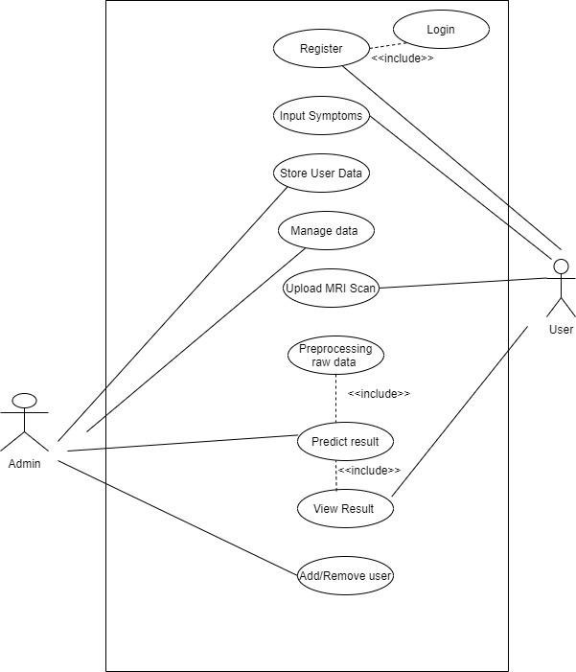

**2.4 Use Case Description**

|  |  |  |
| --- | --- | --- |
| Actors | Use Case | Description |
| User | Register | Register into the system |
| Log in | Log into the system |
| Input Symptoms | Enter the symptoms |
| Upload MRI Scan | Upload the Magnetic Resonance Image |
| View the predicted result | Users will be able to view the displayed results. |
| Log out | Log out of the system |
| Admin | Collect the user data | Data that is inserted by user |
| Make prediction | Preprocessing the data make a prediction whether tumor is present or not |
| Display Result | Result is displayed |

**2.5 Activity Diagram :**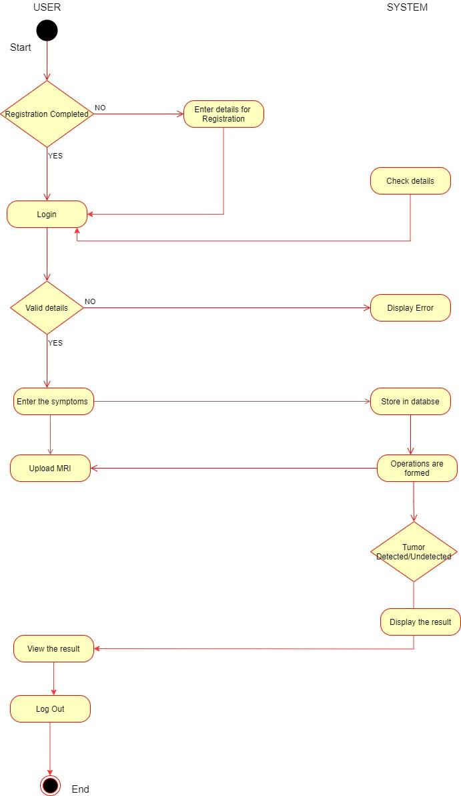

**3.DATA MODEL AND DESCRIPTION**

**3.1 Database :**

|  |  |  |  |
| --- | --- | --- | --- |
| **Sr. No.** | **Field name** | **Range of valid for the field** | **Remarks** |
| 1 | Username | Up to 15 characters in length | Name used by the user |
| 2 | Email ID | Up to 15 characters in length | Active email id of the user |
| 3 | Password | Up to 15 characters in length | Password must include atleast one capital letter and one digit and one special character |
| 4 | MRI photo | Upto 500 KB | Upload MRI of brain of the user |
| 5 | Symptoms | Upto 100 characters in length | Enter the symptoms |

**3.2 Complete data model :**

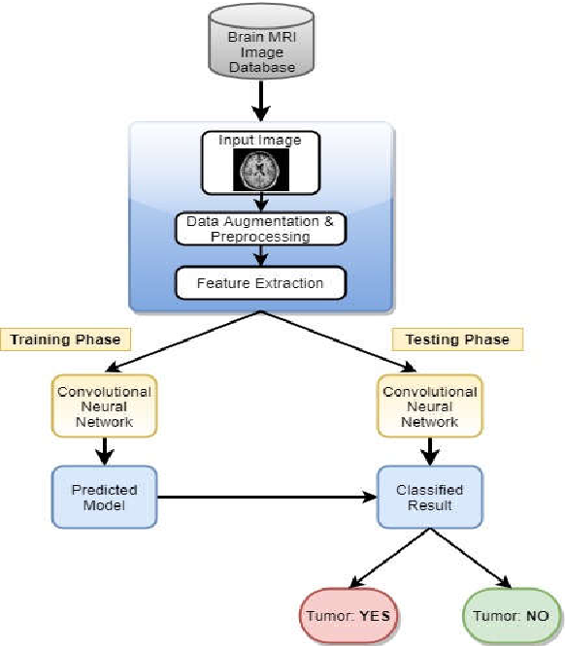

**4.FUNCTIONAL MODEL AND DESCRIPTION**

**4.1 Class Diagram :**

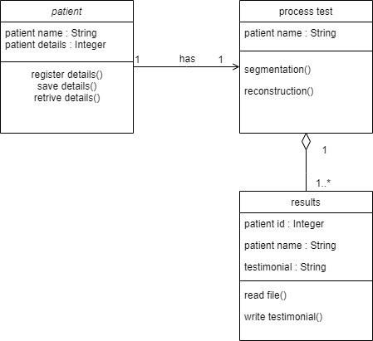

**5. BEHAVIORAL MODEL DESCRIPTION**

**5.1 Events**

* User Login- The system allows the user to create an account if the user is a new user and store his/her information in the database. If the user already has an account then the system checks the information provided by the user for logging in for authentication and the user logs in his/her account.
* User Logout- The system will log the user out of his/her account.
* Upload File- System will store the image provided by the user to the database.

**5.2 States**

* Registration/Login - User will register or login in the system
* User Input- System will take the input from the user in the form of an image
* Predict the presence and and if yes then type of Brain Tumor
* Display Result - The predicted result is displayed by the system

**5.3 State Chart Diagram**

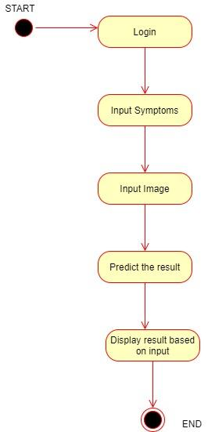

**6.RESTRICTIONS LIMITATION AND CONSTRAINTS**

1. Prediction accuracy is based on a collected database.
2. The bias generated from the model can reduce the efficiency.
3. The application runs on a local machine.
4. Excessive computational cost and also required manual interaction.

**7. DETAILED DESIGN**

**7.1 Components**

**1) User Registration:-**

User will register on the system with credentials.

**2) User Verification:-**

If a user has a verified registration, verification will be performed during user login. If verification is successful, the user will successfully login into the system.

**3) Input Symptoms:-**

In this component the user can input his symptoms in the system. These symptoms can be used as a dataset for the research department to detect rare symptoms of brain tumour.

**4) Upload MRI:-**

User will upload MRI images from the device in this component.

**5) Operations:-**

Based on the input symptoms and images, the system will perform operations to detect the presence of tumor.

**6) Results:-**

Based on the operations performed in the previous component, the system will produce the results.

**7.2 Pseudocode: -**

1. User will register on the system.
2. If user is already registered then

a. User will login to the system

b. Else user will register into the system.

1. Ask the user to enter symptoms as text data into the system.

a. This user data will be stored in the database.

1. Ask the user to Upload MRI images from the device.
2. The selected MR image is pre-processed using various techniques.
3. The pre-processed image is then subjected to segmentation and then feature extraction.
4. If tumor is not detected

a. User is notified that there is no presence of tumors.

b. Else if tumor is detected then user is notified the presence of tumor.

1. The classification is performed using CNN algorithm, and the result is displayed to the user

**8. VALIDATION CRITERIA**

**8.1 Test Plan:**

|  |  |  |  |
| --- | --- | --- | --- |
| **Sr. No.** | **Test Case Title** | **Description** | **Expected Outcome** |
| 1 | Successful User Login | The user must be able to login to the system in order to access it. | Login should be successful and then the user should be able to access the system. |
| 2 | Unsuccessful User Login | The user must be able to login to the system in order to access it. | Login fails due to incorrect details provided. |
| 3 | Symptoms | The user must be able to add symptoms. | Symptoms should be successfully entered by the user. |
| 4 | MRI upload | The user must be able to upload the MRI copy of the brain in the system. | Uploading process should be successful. |
| 5 | Detection of the Brain Tumor | The system should be able to detect the presence of tumor in the brain. | Tumor must be detected and the user must get to know about the result. |
| 6 | Successful User Logout | The user must be able to logout from the system. | Logout should be successful. |
| 7 | Unsuccessful User Logout | The user must be able to logout from the system. | Logout fails. |

**8.2 Expected Final Software Response:**

Detection of the presence of Brain Tumor.

Information about the type of Brain Tumor detected.

**9.PRELIMINARY SCHEDULE AND BUDGET**

|  |  |  |  |
| --- | --- | --- | --- |
| **Task name** | **Duration** | **Start date** | **End date** |
| Domain Selection | 10 days | 02/08/2021 | 12/08/2021 |
| Analysis of various problems suitable in the selected domain | 10 days | 02/08/2021 | 12/08/2021 |
| Domain finalization | 2 day | 12/08/2021 | 14/08/2021 |
| Problems detected | 5 days | 16/08/2021 | 21/08/2021 |
| Research on various problem statements detected | 5 days | 16/08/2021 | 21/08/2021 |
| Problem Statement finalization | 12 days | 22/08/2021 | 04/09/2021 |
| Documentation | 14 days | 17/09/2021 | 30/09/2021 |
| Presentation | 1 day | 2/10/2021 | 3/10/2021 |

**10. REFERENCES**

1. N. N. Gopal and M. Karnan. Diagnose brain tumor through MRI using image processing clustering algorithms such as Fuzzy C Means along with intelligent optimization techniques. In IEEE International Conference on Computational Intelligence and Computing Research (ICCIC), pages 1–4, Dec 2010.
2. H. Najadat, Y. Jaﬀal, O. Darwish, and N. Yasser. A classiﬁer to detect abnormality in CT brain images. I The 2011 IAENG International Conference on Data Mining and Applications, pages 374–377, Mar 2011.
3. M. F. Othman and M. A. M. Basri. Probabilistic neural network for brain tumor classiﬁcation. In Second International Conference on Intelligent Systems, Modelling and Simulation (ISMS), pages 136–138, Jan

2011.

1. D. F. Specht. Probabilistic neural networks. Neural Networks, 3(1):109–118, 1990